**Operational Document:**

**User needs to input the text file name as shown:**

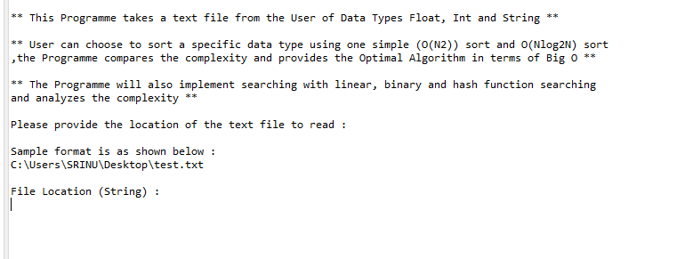

**The Program Sorts out String, Float and Integer from the file:**

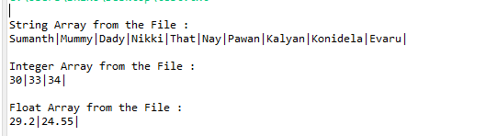

**User needs to select the Data type on which the Sorting and Searching Algos should apply on:**

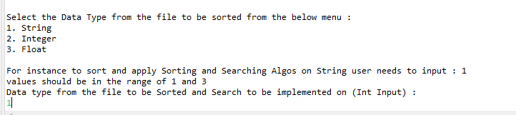

**User needs to select searching from the two groups (O(N2) and O(N*LogN2)) present:**

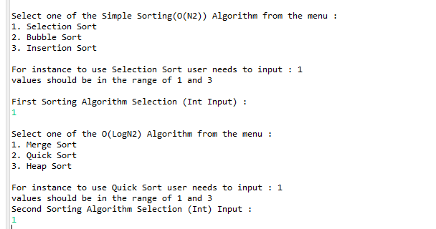

**The Programs prints the sorted elements**

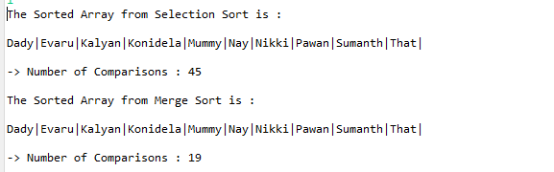

**We need to give the target to for the Program to find in the array the program sorts elements using binary, linear and hash search:**

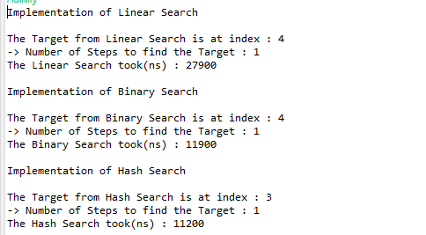

**Note: Hash index is different as index in hash array is different than normal array**